**SMART GARBAGE COLLECTOR SYSTEM**

**Abstract:-**

In our city many times we see that the garbage bins or dustbins placed at public places are overflowing. It creates unhygienic conditions for people. Also it creates ugliness to that place. At the same time bad smells also spread. To avoid all such situations we are going to implement a project called “ SMART GARBAGE COLLECTION SYSTEM ”using RF and GSM technology. In these dustbins are interfaced with microcontroller based system having IR wireless system.

smart garbage collectionsystem collects the garbage separately such as dry garbage to separate container with the help of pipe and separate wet garbage to separate container. The display is used to show the container level in percentage. If the container is full at that it will detect by sensors and message is sent to the nearest municipal office through the GSM module.

Hence the smart garbage collection system can be used in smart cities to collect the garbage separately (dry/wet).And it will help to prevent the environmental pollution.

Also we use an automation system to sort dry and wet garbage using moisture sensor which helps to separate degradable and non degradable waste.



**INTRODUCTION**

The mixing waste management is a big challenge in the any country. The smart garbage collection system is used of the smart home and smart city. The system is used of the separate garbage such as dry garbage is separate container and the wet garbage is separate container with the help of a motor mechanism and the IR sensor though. The garbage is place of motor mechanism then the IR sensor detects and the moisture sensor is the find out the garbage is wet or dry. Suppose the garbage is wet then the motor mechanism is rotated to left side and if the garbage is dry then motormechanism is rotated of right side and the garbage is collected in the container. when the garbage container is full then it will display to the nearest municipal office that the container is full and send the code or address. And the municipal office will inform of the garbage collector driver via sms through GSM module .The total process is wireless through.

An efficient waste management is a pre requisition for maintain a safe and green environment as there are increasing all kinds of waste disposal. There are many technologies are used for waste collection as well as for well managed recycling. The Information gathering is big and cumbersome. The concurrent effects of a fast national growth rate, of a large and dense residential area and a pressing demand for urban environmental protection create a challenging framework for waste management. The complexity of context and procedures is indeed a primary concern of local municipal authorities due to problems related to the collection, transportation and processing of residential solid waste today the garbage collection is manual which takes a lot of efforts and is time consuming.

In this project humans and vehicles were used to do that work and here we are using automatic technique to detect garbage level in Garbage Can. For that, ID number is given to each can. Also as soon as the Garbage Can is full / over flowing then a SMS is sent to the server from where all the garbage collection vehicles are allotted.

**Block diagram:-**

**Transmitter section**

Power supply

CONTROLLER

ATMEGA16

LCD

Moisture sensor

MOTOR

IR sensor1

RF TRANSMITTER

IR sensor 2

IR sensor3

Temperature sensor

**Receiver section**

Power supply

ATMEGA16

LCD

RF receiver

GSM

**CIRCUIT DIAGRAM:**

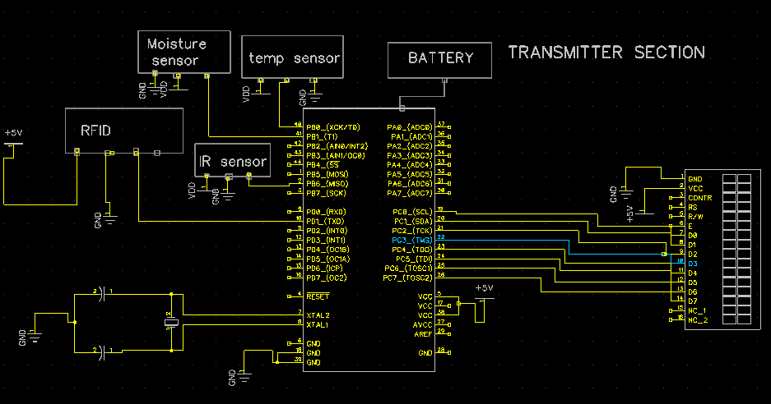

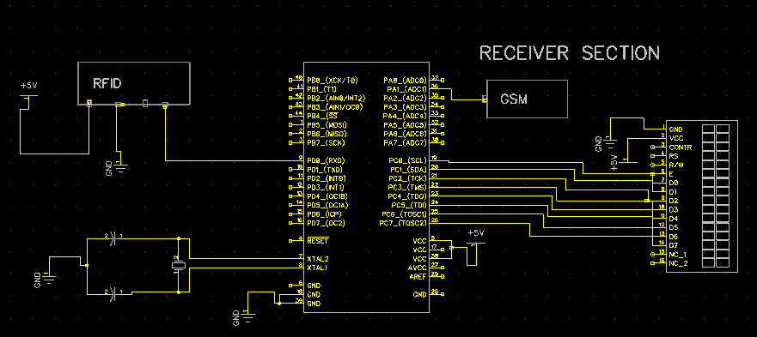

**POWER SUPPLY CALCULATION:**

### Types of Power Supply

There are many types of power supply. Most are designed to convert high voltage AC mains electricity to a suitable DC voltage supply for electronics circuits and other devices. A power supply can by broken down into a series of blocks, each of which performs a particular function.

A 5V regulated supply

. 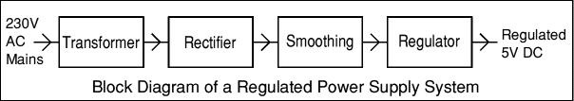

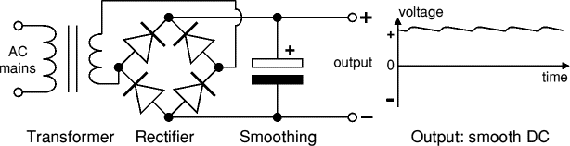

Each of the blocks is described in more detail below:

* [Transformer](http://www.kpsec.freeuk.com/powersup.htm#transformer) - steps down high voltage AC mains to low voltage AC.
* [Rectifier](http://www.kpsec.freeuk.com/powersup.htm#rectifier) - converts AC to DC, but the DC output is varying.
* [Smoothing](http://www.kpsec.freeuk.com/powersup.htm#smoothing) - smooths the DC from varying greatly to a small ripple.
* [Regulator](http://www.kpsec.freeuk.com/powersup.htm#regulator) - eliminates ripple by setting DC output to a fixed voltage.

### Transformer, photograph © Rapid ElectronicsTransformer

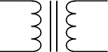

Transformer circuit symbol

Transformers convert AC electricity from one voltage to another with little loss of power. Transformers work only with AC and this is one of the reasons why mains electricity is AC.

Step-up transformers increase voltage, step-down transformers reduce voltage. Most power supplies use a step-down transformer to reduce the dangerously high mains voltage (230V in UK) to a safer low voltage.

The input coil is called the **primary** and the output coil is called the **secondary**. There is no electrical connection between the two coils, instead they are linked by an alternating magnetic field created in the soft-iron core of the transformer. The two lines in the middle of the circuit symbol represent the core.

Transformers waste very little power so the power out is (almost) equal to the power in. Note that as voltage is stepped down current is stepped up.

The ratio of the number of turns on each coil, called the **turns ratio**, determines the ratio of the voltages. A step-down transformer has a large number of turns on its primary (input) coil which is connected to the high voltage mains supply, and a small number of turns on its secondary (output) coil to give a low output voltage.

|  |  |  |  |  |  |
| --- | --- | --- | --- | --- | --- |
| turns ratio = | Vp | = | Np | and | power out = power in |
| Vs | Ns | Vs × Is = Vp × Ip |

|  |  |  |
| --- | --- | --- |
| Vp = primary (input) voltage Np = number of turns on primary coil Ip  = primary (input) current |  | Vs = secondary (output) voltage Ns = number of turns on secondary coil Is  = secondary (output) current |

#### Bridge rectifier

A bridge rectifier can be made using four individual diodes, but it is also available in special packages containing the four diodes required. It is called a full-wave rectifier because it uses all the AC wave (both positive and negative sections). 1.4V is used up in the bridge rectifier because each diode uses 0.7V when conducting and there are always two diodes conducting, as shown in the diagram below. Bridge rectifiers are rated by the maximum current they can pass and the maximum reverse voltage they can withstand (this must be at least three times the supply [RMS](http://www.kpsec.freeuk.com/acdc.htm#rms) voltage so the rectifier can withstand the peak voltages). Please see the [Diodes](http://www.kpsec.freeuk.com/components/diode.htm#bridge) page for more details, including pictures of bridge rectifier

### Root Mean Square (RMS) Values

The value of an AC voltage is continually changing from zero up to the positive peak, through zero to the negative peak and back to zero again. Clearly for most of the time it is less than the peak voltage, so this is not a good measure of its real effect.

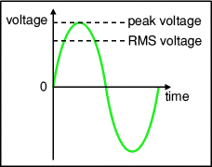

Instead we use the **root mean square voltage** (VRMS) which is 0.7 of the **peak voltage** (Vpeak):

**VRMS = 0.7 × Vpeak   and   Vpeak = 1.4 × VRMS**

These equations also apply to **current**.   
They are only true for sine waves (the most common type of AC) because the 0.7 and 1.4 are different values for other shapes.

The **RMS value** is the **effective value** of a varying voltage or current. It is the equivalent steady DC (constant) value which gives the same effect.

For example a lamp connected to a **6V RMS AC** supply will light with the same brightness when connected to a **steady 6V DC** supply. However, the lamp will be dimmer if connected to a **6V peak AC** supply because the RMS value of this is only 4.2V (it is equivalent to a steady 4.2V DC).

You may find it helps to think of the RMS value as a sort of average, but please remember that it is NOT really the average! In fact the average voltage (or current) of an AC signal is zero because the positive and negative parts exactly cancel out

**Bridge rectifier**  
Alternate pairs of diodes conduct, changing over  
the connections so the alternating directions of  
AC are converted to the one direction of DC.

Smoothing

Smoothing is performed by a large value [electrolytic capacitor](http://www.kpsec.freeuk.com/components/capac.htm#polarised) connected across the DC supply to act as a reservoir, supplying current to the output when the varying DC voltage from the rectifier is falling. The diagram shows the unsmoothed varying DC (dotted line) and the smoothed DC (solid line). The capacitor charges quickly near the peak of the varying DC, and then discharges as it supplies current to the output.   
  
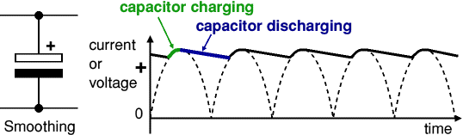

Note that smoothing significantly increases the average DC voltage to almost the peak value (1.4 × [RMS](http://www.kpsec.freeuk.com/acdc.htm#rms) value). For example 6V RMS AC is rectified to full wave DC of about 4.6V RMS (1.4V is lost in the bridge rectifier), with smoothing this increases to almost the peak value giving 1.4 × 4.6 = 6.4V smooth DC.

Smoothing is not perfect due to the capacitor voltage falling a little as it discharges, giving a small **ripple voltage**. For many circuits a ripple which is 10% of the supply voltage is satisfactory and the equation below gives the required value for the smoothing capacitor. A larger capacitor will give less ripple. The capacitor value must be doubled when smoothing half-wave DC.

|  |
| --- |
|  |

|  |  |
| --- | --- |
| Smoothing capacitor for 10% ripple, C = | 5 × Io |
| Vs × f |

C  = smoothing capacitance in farads (F)  
Io  = output current from the supply in amps (A)  
Vs = supply voltage in volts (V), this is the peak value of the unsmoothed DC  
f    = frequency of the AC supply in hertz (Hz), 50Hz in the UK

**Voltage regulator**

Voltage regulator ICs are available with fixed (typically 5, 12 and 15V) or variable output voltages. They are also rated by the maximum current they can pass. Negative voltage regulators are available, mainly for use in dual supplies. Most regulators include some automatic protection from excessive current ('overload protection') and overheating ('thermal protection').

Many of the fixed voltage regulator ICs have 3 leads and look like power transistors, such as the 7805 +5V 1A regulator shown on the right. They include a hole for attaching a [heatsink](http://www.kpsec.freeuk.com/components/heatsink.htm) if necessary.

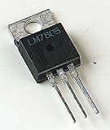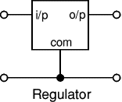

**POWER SUPPLY:**

**Regulator:**

Regulator is used to convert unregulated dc voltage to regulated dc voltage.

**Regulator IC 7812:**

We require fixed regulated voltage of 12V with output current of 1A.Here we select three terminal Positive voltage regulators IC 7812 which gives 12V dc output voltage.

Input to this regulator IC must be greater than the output voltage plus drop across the IC. The voltage drop across IC7805 is 2.5V.

So,

Input to regulator = output voltage + drop across IC7812

= 12+2.5

= 14.5V

For proper output input to the regulator must be greater than 14.5V.

**Regulator IC 7805:**

As we require one more supply of 5V.We can use same filtered output to get 5V dc .For this purpose, we are using the IC 7805 which gives 5V dc output voltage. The input to this IC should be in between 8V and 20V. Hence we can use this regulator IC 7805 in parallel with regulator IC 7812.

Hardware used:-

1. Atmega 16 controller
2. L293D
3. Temperature sensor
4. Rftransreceiver
5. Lcd
6. Ir sensor
7. GSM
8. Motor
9. Moisture sensor

**ATMEGA 16 controller**

**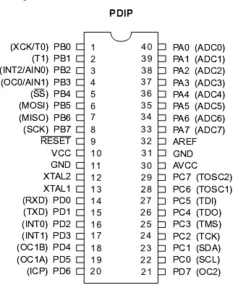**

**Fig:-Pin Diagram**

ATmega16 is an 8-bit high performance microcontroller of Atmel’s Mega [AVR](http://www.engineersgarage.com/articles/avr-microcontroller) family with low power consumption. Atmega16 is based on enhanced RISC (Reduced Instruction Set Computing, Know more about [RISC and CISC Architecture](http://www.engineersgarage.com/articles/risc-and-cisc-architecture)) architecture with 131 powerful instructions. Most of the instructions execute in one machine cycle. Atmega16 can work on a maximum frequency of 16MHz.ATmega16 has 16 KB programmable flash memory, static RAM of 1 KB and EEPROM of 512 Bytes. The endurance cycle of flash memory and EEPROM is 10,000 and 100,000, respectively. ATmega16 is a 40 pin microcontroller. There are 32 I/O (input/output) lines which are divided into four 8-bit ports designated as PORTA, PORTB, PORTC and PORTD.ATmega16 has various in-built peripherals like [USART](http://www.engineersgarage.com/embedded/avr-microcontroller-projects/serial-communication-atmega16-usart), [ADC](http://www.engineersgarage.com/embedded/avr-microcontroller-projects/adc-circuit), [Analog Comparator](http://www.engineersgarage.com/embedded/avr-microcontroller-projects/analog-comparator-circuit), [SPI](http://www.engineersgarage.com/embedded/avr-microcontroller-projects/spi-serial-peripheral-interface-tutorial-circuit), [JTAG](http://www.engineersgarage.com/embedded/avr-microcontroller-projects/disable-jtag-port) etc. Each I/O pin has an alternative task related to in-built peripherals. The following table shows the pin description of ATmega16.

L293D

The L293D is quadruple high-current half-H drivers.It is designed to provide bidirectional drive currents of up to 600-mA at voltages from 4.5 V to 36 V. Both devices are designed to drive inductive loads such as relays, solenoids, dc and bipolar stepping motors, as well as other high-current/high-voltage loads in positive-supply applications. All inputs are TTL compatible. Each output is a complete totem-pole drive circuit, with a Darlington transistor sink and a pseudo- Darlington source. Drivers are enabled in pairs, with drivers 1 and 2 enabled by 1,2EN and drivers 3 and 4 enabled by 3,4EN. When an enable input is high, the associated drivers are enabled, and their outputs are active and in phase with their inputs. When the enable input is low, those drivers are disabled, and their outputs are off and in the high-impedance state. With the proper data inputs, each pair of drivers forms a full-H (or bridge) reversible drive suitable for solenoid or motor applications.

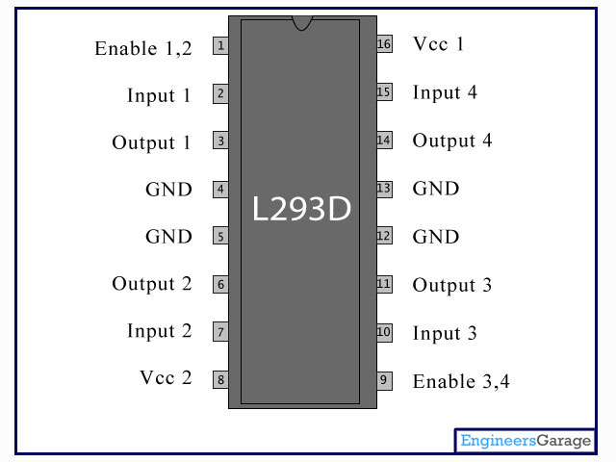

Fig:-L293D IC

**Temperature sensor**

In general,a temperature sensor is a device which is designed specifically to measure the hotness or coldness of an object.LM35 is a precision IC temperature sensor with its output proportional to the temperature (in °C).With LM35,the temperature can be measured more accurately than with a thermistor. It also possess low self heating and does not cause more than 0.1 °C temperature rise in still air. The operating temperature range is from -55°C to 150°C.The LM35’s low output impedance,linear output, and precise inherent calibration make interfacing to readout or control circuitry especially easy.

The LM35 is an integrated circuit sensor that can be used to measure temperature with an electrical output proportional to the temperature (in °C).It can measure temperature more accurately than a using a thermistor. The sensor circuitry is sealed and not subject to oxidation.The LM35 generates a higher output voltage than thermocouples and may not require that the output voltage be amplified.The LM35 has an output voltage that is proportional to the Celsius temperature.The scale factor is .01V/°C.

The LM35 does not require any external calibration or trimming and maintains an accuracy of +/-0.4°C at room temperature and +/-0.8°C over a range of 0°C to +100°C.Another important characteristic of the LM35 is that it draws only 60 micro amps from its supply and possesses a low self-heating capability.The LM35 comes in many different packages such as TO-92 plastic transistor-like package,T0-46 metal can transistor-like package,8-lead surface mount SO-8 small outline package.

There are two transistors in the center of the drawing. One has ten times the emitter area of the other. This means it has one tenth of the current density, since the same current is going through both transistors. This causes a voltage across the resistor R1 that is proportional to the absolute temperature, and is almost linear across the range.The "almost" part is taken care of by a special circuit that straightens out the slightly curved graph of voltage versus temperature.

The amplifier at the top ensures that the voltage at the base of the left transistor (Q1) is proportional to absolute temperature (PTAT) by comparing the output of the two transistors.

The amplifier at the right converts absolute temperature (measured in Kelvin) into either Fahrenheit or Celsius, depending on the part (LM34 or LM35).The little circle with the "i" in it is a constant current source circuit.

The two resistors are calibrated in the factory to produce a highly accurate temperature sensor.

The integrated circuit has many transistors in it -- two in the middle, some in each amplifier, some in the constant current source, and some in the curvature compensation circuit. All of that is fit into the tiny package with three leads.

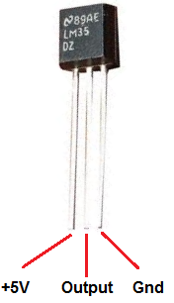

**Rf transreceiver**

An RF module (radio frequency module) is a (usually) small electronic device used to transmit and/or receive radio signals between two devices. In an [embedded system](https://en.wikipedia.org/wiki/Embedded_system) it is often desirable to communicate with another device [wirelessly](https://en.wikipedia.org/wiki/Wireless). This wireless communication may be accomplished through [optical communication](https://en.wikipedia.org/wiki/Free-space_optical_communication) or through [radio](https://en.wikipedia.org/wiki/Radio) frequency (RF) communication. For many applications the medium of choice is RF since it does not require line of sight. RF communications incorporate a [transmitter](https://en.wikipedia.org/wiki/Transmitter) or [receiver](https://en.wikipedia.org/wiki/Receiver_%28radio%29).

RF modules are widely used in electronic design owing to the difficulty of designing radio circuitry. Good electronic radio design is notoriously complex because of the sensitivity of radio circuits and the accuracy of components and layouts required to achieve operation on a specific frequency. In addition, reliable RF communication circuit requires careful monitoring of the manufacturing process to ensure that the RF performance is not adversely affected. Finally, radio circuits are usually subject to limits on radiated emissions, and require [Conformance testing](https://en.wikipedia.org/wiki/Conformance_testing) and certification by a [standardization](https://en.wikipedia.org/wiki/Standardization) organization such as [ETSI](https://en.wikipedia.org/wiki/ETSI) or the U.S. [Federal Communications Commission](https://en.wikipedia.org/wiki/Federal_Communications_Commission) (FCC). For these reasons, design engineers will often design a circuit for an application which requires radio communication and then "drop in" a pre-made radio module rather than attempt a [discrete](https://en.wikipedia.org/wiki/Discrete_device) design, saving time and money on development.

RF modules are most often used in medium and low volume products for consumer applications such as garage door openers, wireless alarm systems, [industrial remote controls](https://en.wikipedia.org/wiki/Remote_controls), smart sensor applications, and [wireless home automation systems](https://en.wikipedia.org/wiki/Home_automation). They are sometimes used to replace older [infra red](https://en.wikipedia.org/wiki/Infra_red) communication designs as they have the advantage of not requiring line-of-sight operation.

Several carrier frequencies are commonly used in commercially available RF modules, including those in the [industrial, scientific and medical (ISM) radio bands](https://en.wikipedia.org/wiki/ISM_band) such as 433.92 MHz, 915 MHz, and 2400 MHz. These frequencies are used because of national and international regulations governing the used of radio for communication. [Short Range Devices](https://en.wikipedia.org/wiki/Short_Range_Devices) may also use frequencies available for unlicensed such as 315 MHz and 868 MHz.

RF modules may comply with a defined protocol for RF communications such as [Zigbee](https://en.wikipedia.org/wiki/Zigbee), [Bluetooth low energy](https://en.wikipedia.org/wiki/Bluetooth_low_energy), or [Wi-Fi](https://en.wikipedia.org/wiki/Wi-Fi), or they may implement a [proprietary protocol](https://en.wikipedia.org/wiki/Proprietary_protocol).

### Transmitter modules

An RF transmitter module is a small [PCB sub-assembly](https://en.wikipedia.org/wiki/Printed_Circuit_Board_Assembly) capable of transmitting a radio wave and [modulating](https://en.wikipedia.org/wiki/Modulating) that wave to carry data. Transmitter modules are usually implemented alongside a [micro controller](https://en.wikipedia.org/wiki/Micro_controller) which will provide data to the module which can be transmitted. RF transmitters are usually subject to [regulatory requirements](https://en.wikipedia.org/wiki/Regulation) which dictate the maximum allowable [transmitter power output](https://en.wikipedia.org/wiki/Transmitter_power_output), [harmonics](https://en.wikipedia.org/wiki/Harmonics), and band edge requirements.

### Receiver modules

An RF receiver module receives the modulated RF signal, and [demodulates](https://en.wikipedia.org/wiki/Demodulation) it. There are two types of RF receiver modules: [superheterodyne receivers](https://en.wikipedia.org/wiki/Superheterodyne_receiver) and [super-regenerative receivers](https://en.wikipedia.org/wiki/Regenerative_circuit). Super-regenerative modules are usually low cost and low power designs using a series of amplifiers to extract modulated data from a carrier wave. Super-regenerative modules are generally imprecise as their frequency of operation varies considerably with temperature and power supply voltage.[[citation needed](https://en.wikipedia.org/wiki/Wikipedia:Citation_needed)] Superheterodyne receivers have a performance advantage over super-regenerative; they offer increased accuracy and stability over a large [voltage](https://en.wikipedia.org/wiki/Voltage) and temperature range. This stability comes from a fixed crystal design which in the past tended to mean a comparatively more expensive product. However, advances in receiver chip design now mean that currently there is little price difference between superheterodyne and super-regenerative receiver modules.

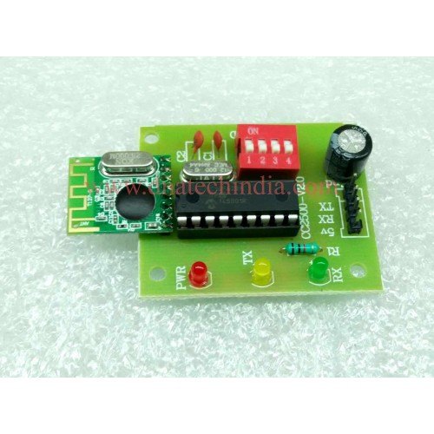

Fig:-RF Module

**LCD**

A liquid-crystal display (LCD) is a [flat-panel display](https://en.wikipedia.org/wiki/Flat_panel_display) or other [electronically modulated optical device](https://en.wikipedia.org/wiki/Electro-optic_modulator) that uses the light-modulating properties of [liquid crystals](https://en.wikipedia.org/wiki/Liquid_crystal). Liquid crystals do not emit light directly, instead using a [backlight](https://en.wikipedia.org/wiki/Backlight) or [reflector](https://en.wikipedia.org/wiki/Reflector_%28photography%29) to produce images in color or [monochrome](https://en.wikipedia.org/wiki/Monochrome).[[1]](https://en.wikipedia.org/wiki/Liquid-crystal_display#cite_note-1) LCDs are available to display arbitrary images (as in a general-purpose computer display) or fixed images with low information content, which can be displayed or hidden, such as preset words, digits, and [7-segment](https://en.wikipedia.org/wiki/7-segment) displays, as in a [digital clock](https://en.wikipedia.org/wiki/Digital_clock). They use the same basic technology, except that arbitrary images are made up of a large number of small [pixels](https://en.wikipedia.org/wiki/Pixel), while other displays have larger elements.

LCDs are used in a wide range of applications including [computer monitors](https://en.wikipedia.org/wiki/Computer_monitor), [televisions](https://en.wikipedia.org/wiki/Television), [instrument panels](https://en.wikipedia.org/wiki/Dashboard), [aircraft cockpit displays](https://en.wikipedia.org/wiki/Flight_instruments), and indoor and outdoor signage. Small LCD screens are common in portable consumer devices such as [digital cameras](https://en.wikipedia.org/wiki/Digital_camera), [watches](https://en.wikipedia.org/wiki/Watch), [calculators](https://en.wikipedia.org/wiki/Calculator), and [mobile telephones](https://en.wikipedia.org/wiki/Mobile_telephone), including [smart-phones](https://en.wikipedia.org/wiki/Smartphone). LCD screens are also used on [consumer electronics](https://en.wikipedia.org/wiki/Consumer_electronics) products such as DVD players, video game devices and [clocks](https://en.wikipedia.org/wiki/Clock). LCD screens have replaced heavy, bulky [cathode ray tube](https://en.wikipedia.org/wiki/Cathode_ray_tube) (CRT) displays in nearly all applications. LCD screens are available in a wider range of screen sizes than CRT and [plasma displays](https://en.wikipedia.org/wiki/Plasma_display), with LCD screens available in sizes ranging from tiny [digital watches](https://en.wikipedia.org/wiki/Digital_watch) to huge, big-screen [television set](https://en.wikipedia.org/wiki/Television_set).

Since LCD screens do not use phosphors, they do not suffer [image burn-in](https://en.wikipedia.org/wiki/Screen_burn-in) when a static image is displayed on a screen for a long time (e.g., the table frame for an aircraft schedule on an indoor sign). LCDs are, however, susceptible to [image persistence](https://en.wikipedia.org/wiki/Image_persistence).[[2]](https://en.wikipedia.org/wiki/Liquid-crystal_display#cite_note-Fujitsu-2) The LCD screen is more energy-efficient and can be disposed of more safely than a CRT can. Its low electrical power consumption enables it to be used in [battery](https://en.wikipedia.org/wiki/Battery_%28electricity%29)-powered [electronic](https://en.wikipedia.org/wiki/Electronics) equipment more efficiently than CRTs can be. By 2008, annual sales of televisions with LCD screens exceeded sales of CRT units worldwide, and the CRT became obsolete for most purposes.

Each [pixel](https://en.wikipedia.org/wiki/Pixel) of an LCD typically consists of a layer of [molecules](https://en.wikipedia.org/wiki/Molecule) aligned between two [transparent](https://en.wikipedia.org/wiki/Transparency_%28optics%29) [electrodes](https://en.wikipedia.org/wiki/Electrode), and two [polarizing](https://en.wikipedia.org/wiki/Polarizer) [filters](https://en.wikipedia.org/wiki/Filter_%28optics%29) (parallel and perpendicular), the axes of transmission of which are (in most of the cases) perpendicular to each other. Without the [liquid crystal](https://en.wikipedia.org/wiki/Liquid_crystal) between the polarizing filters, light passing through the first filter would be blocked by the second (crossed) polarizer. Before an [electric field](https://en.wikipedia.org/wiki/Electric_field) is applied, the orientation of the liquid-crystal molecules is determined by the alignment at the surfaces of electrodes. In a twisted nematic (TN) device, the surface alignment directions at the two electrodes are perpendicular to each other, and so the molecules arrange themselves in a [helical](https://en.wikipedia.org/wiki/Helix) structure, or twist. This induces the rotation of the polarization of the incident light, and the device appears gray. If the applied voltage is large enough, the liquid crystal molecules in the center of the layer are almost completely untwisted and the polarization of the [incident light](https://en.wikipedia.org/wiki/Incident_light) is not rotated as it passes through the liquid crystal layer. This light will then be mainly polarized [perpendicular](https://en.wikipedia.org/wiki/Perpendicular) to the second filter, and thus be blocked and the [pixel](https://en.wikipedia.org/wiki/Pixel) will appear black. By controlling the voltage applied across the liquid crystal layer in each pixel, light can be allowed to pass through in varying amounts thus constituting different levels of gray. Color LCD systems use the same technique, with color filters used to generate red, green, and blue pixels.[[3]](https://en.wikipedia.org/wiki/Liquid-crystal_display#cite_note-3)

The optical effect of a TN device in the voltage-on state is far less dependent on variations in the device thickness than that in the voltage-off state. Because of this, TN displays with low information content and no backlighting are usually operated between crossed polarizers such that they appear bright with no voltage (the eye is much more sensitive to variations in the dark state than the bright state). As most of 2010-era LCDs are used in television sets, monitors and smartphones, they have high-resolution matrix arrays of pixels to display arbitrary images using backlighting with a dark background. When no image is displayed, different arrangements are used. For this purpose, TN LCDs are operated between parallel polarizers, whereas [IPS LCDs](https://en.wikipedia.org/wiki/IPS_panel) feature crossed polarizers. In many applications IPS LCDs have replaced TN LCDs, in particular in [smartphones](https://en.wikipedia.org/wiki/Smartphone) such as [iPhones](https://en.wikipedia.org/wiki/IPhone). Both the liquid crystal material and the alignment layer material contain [ionic compounds](https://en.wikipedia.org/wiki/Ionic_compound). If an electric field of one particular polarity is applied for a long period of time, this ionic material is attracted to the surfaces and degrades the device performance. This is avoided either by applying an [alternating current](https://en.wikipedia.org/wiki/Alternating_current) or by reversing the polarity of the electric field as the device is addressed (the response of the liquid crystal layer is identical, regardless of the polarity of the applied field).

Displays for a small number of individual digits or fixed symbols (as in [digital watches](https://en.wikipedia.org/wiki/Digital_watch) and [pocket calculators](https://en.wikipedia.org/wiki/Pocket_calculator)) can be implemented with independent electrodes for each segment. In contrast, full [alphanumeric](https://en.wikipedia.org/wiki/Alphanumeric) or variable graphics displays are usually implemented with pixels arranged as a matrix consisting of electrically connected rows on one side of the LC layer and columns on the other side, which makes it possible to address each pixel at the intersections. The general method of matrix addressing consists of sequentially addressing one side of the matrix, for example by selecting the rows one-by-one and applying the picture information on the other side at the columns row-by-row. For details on the various matrix addressing schemes see [Passive-matrix and active-matrix addressed LCDs](https://en.wikipedia.org/wiki/Liquid-crystal_display#Passive_and_active-matrix).

**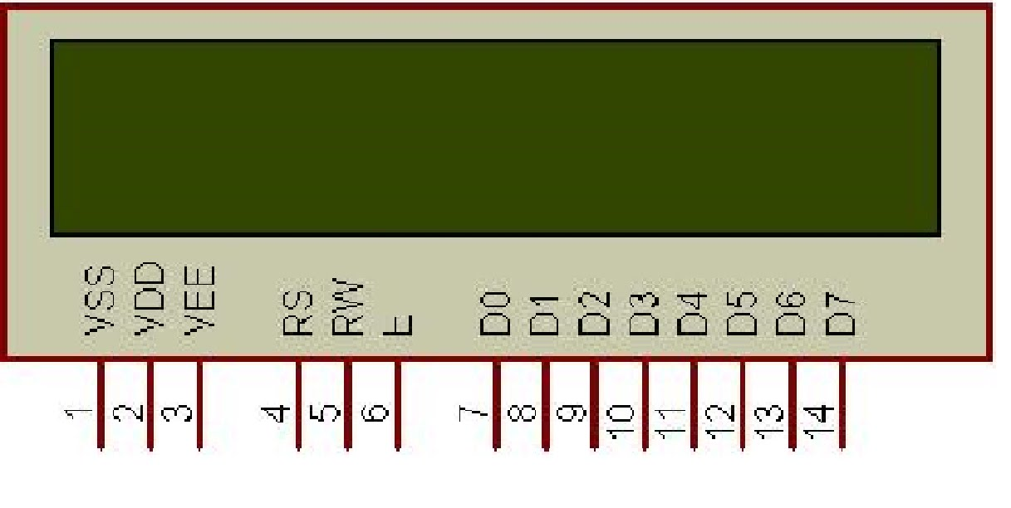**

Fig:-LCD Pin out

**IR sensor**

Infrared radiation, or simply infrared or IR, is [electromagnetic radiation](https://en.wikipedia.org/wiki/Electromagnetic_radiation) (EMR) with longer [wavelengths](https://en.wikipedia.org/wiki/Wavelength) than those of [visible light](https://en.wikipedia.org/wiki/Light), and is therefore invisible, although it is sometimes loosely called infrared light. It extends from the nominal [red](https://en.wikipedia.org/wiki/Red) edge of the [visible spectrum](https://en.wikipedia.org/wiki/Visible_spectrum) at 700 [nanometers](https://en.wikipedia.org/wiki/Nanometre) ([frequency](https://en.wikipedia.org/wiki/Frequency_spectrum) 430 [THz](https://en.wikipedia.org/wiki/Terahertz_%28unit%29)), to 1000000 nm (300 [GHz](https://en.wikipedia.org/wiki/GHz))[[1]](https://en.wikipedia.org/wiki/Infrared#cite_note-1) (although people can see infrared up to at least 1050 nm in experiments[[2]](https://en.wikipedia.org/wiki/Infrared#cite_note-Sliney1976-2)[[3]](https://en.wikipedia.org/wiki/Infrared#cite_note-LynchLivingston2001-3)[[4]](https://en.wikipedia.org/wiki/Infrared#cite_note-Dash2009-4)[[5]](https://en.wikipedia.org/wiki/Infrared#cite_note-Saidman1933-5)). Most of the [thermal radiation](https://en.wikipedia.org/wiki/Thermal_radiation) emitted by objects near room temperature is infrared. Like all EMR, IR carries [radiant energy](https://en.wikipedia.org/wiki/Radiant_energy), and behaves [both](https://en.wikipedia.org/wiki/Wave%E2%80%93particle_duality) like a wave and like its [quantum](https://en.wikipedia.org/wiki/Quantum) particle, the [photon](https://en.wikipedia.org/wiki/Photon).

Infrared was discovered in 1800 by astronomer Sir [William Herschel](https://en.wikipedia.org/wiki/William_Herschel), who discovered a type of invisible radiation in the spectrum lower in energy than red light, by means of its effect on a thermometer.[[6]](https://en.wikipedia.org/wiki/Infrared#cite_note-6) Slightly more than half of the total energy from the Sun was eventually found to arrive on Earth in the form of infrared. The balance between absorbed and emitted infrared radiation has a critical effect on Earth's [climate](https://en.wikipedia.org/wiki/Climate).

Infrared radiation is emitted or absorbed by [molecules](https://en.wikipedia.org/wiki/Molecule) when they change their [rotational-vibrational](https://en.wikipedia.org/wiki/Infrared_spectroscopy) movements. It excites [vibrational](https://en.wikipedia.org/wiki/Vibration) modes in a [molecule](https://en.wikipedia.org/wiki/Molecule) through a change in the [dipole moment](https://en.wikipedia.org/wiki/Molecular_dipole_moment), making it a useful frequency range for study of these energy states for molecules of the proper symmetry. [Infrared spectroscopy](https://en.wikipedia.org/wiki/Infrared_spectroscopy) examines absorption and transmission of [photons](https://en.wikipedia.org/wiki/Photon) in the infrared range.[[7]](https://en.wikipedia.org/wiki/Infrared#cite_note-7)

Infrared radiation is used in industrial, scientific, and medical applications. Night-vision devices using active near-infrared illumination allow people or animals to be observed without the observer being detected. [Infrared astronomy](https://en.wikipedia.org/wiki/Infrared_astronomy) uses sensor-equipped [telescopes](https://en.wikipedia.org/wiki/Telescopes) to penetrate dusty regions of space such as [molecular clouds](https://en.wikipedia.org/wiki/Molecular_cloud), detect objects such as [planets](https://en.wikipedia.org/wiki/Planet), and to view highly [red-shifted](https://en.wikipedia.org/wiki/Redshift) objects from the early days of the [universe](https://en.wikipedia.org/wiki/Universe).[[8]](https://en.wikipedia.org/wiki/Infrared#cite_note-ir_astronomy-8) Infrared thermal-imaging cameras are used to detect heat loss in insulated systems, to observe changing blood flow in the skin, and to detect overheating of electrical apparatuses.

Thermal-infrared imaging is used extensively for military and civilian purposes. Military applications include [target acquisition](https://en.wikipedia.org/wiki/Target_acquisition), surveillance, [night vision](https://en.wikipedia.org/wiki/Night_vision), homing, and tracking. Humans at normal body temperature radiate chiefly at wavelengths around 10 μm (micrometers). Non-military uses include [thermal efficiency](https://en.wikipedia.org/wiki/Thermal_efficiency) analysis, environmental monitoring, industrial facility inspections, remote temperature sensing, short-ranged [wireless communication](https://en.wikipedia.org/wiki/Wireless_communication), [spectroscopy](https://en.wikipedia.org/wiki/Spectroscopy), and [weather forecasting](https://en.wikipedia.org/wiki/Weather_forecasting).

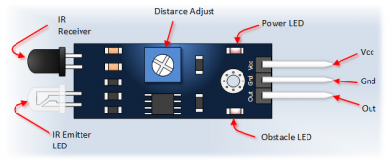

**GSM**

GSM (Global System for Mobile Communications, originally Groupe SpécialMobile) is a standard developed by the [European Telecommunications Standards Institute](https://en.wikipedia.org/wiki/European_Telecommunications_Standards_Institute) (ETSI) to describe the protocols for second-generation ([2G](https://en.wikipedia.org/wiki/2G)) digital [cellular networks](https://en.wikipedia.org/wiki/Cellular_network) used by [mobile phones](https://en.wikipedia.org/wiki/Mobile_phone), first deployed in Finland in July 1991.[[2]](https://en.wikipedia.org/wiki/GSM#cite_note-2) As of 2014 it has become the de facto global standard for mobile communications – with over 90% market share, operating in over 219 countries and territories.[[3]](https://en.wikipedia.org/wiki/GSM#cite_note-3)

2G networks developed as a replacement for first generation ([1G](https://en.wikipedia.org/wiki/1G)) analog cellular networks, and the GSM standard originally described as a digital, circuit-switched network optimized for [full duplex](https://en.wikipedia.org/wiki/Duplex_%28telecommunications%29#Full_duplex) voice [telephony](https://en.wikipedia.org/wiki/Telephony). This expanded over time to include data communications, first by circuit-switched transport, then by [packet](https://en.wikipedia.org/wiki/Network_packet) data transport via [GPRS](https://en.wikipedia.org/wiki/GPRS) (General Packet Radio Services) and [EDGE](https://en.wikipedia.org/wiki/EDGE) (Enhanced Data rates for GSM Evolution or EGPRS).

Subsequently, the [3GPP](https://en.wikipedia.org/wiki/3GPP) developed third-generation ([3G](https://en.wikipedia.org/wiki/3G)) [UMTS](https://en.wikipedia.org/wiki/UMTS) standards followed by fourth-generation ([4G](https://en.wikipedia.org/wiki/4G)) [LTE Advanced](https://en.wikipedia.org/wiki/LTE_Advanced) standards, which do not form part of the ETSI GSM standard.

"GSM" is a [trademark](https://en.wikipedia.org/wiki/Trademark) owned by the [GSM Association](https://en.wikipedia.org/wiki/GSM_Association). It may also refer to the (initially) most common voice codec used, [Full Rate](https://en.wikipedia.org/wiki/Full_Rate).

GSM is a [cellular network](https://en.wikipedia.org/wiki/Cellular_network), which means that [cell phones](https://en.wikipedia.org/wiki/Cell_phone) connect to it by searching for cells in the immediate vicinity. There are five different cell sizes in a GSM network—[macro](https://en.wikipedia.org/wiki/Macrocell), [micro](https://en.wikipedia.org/wiki/Microcell), [pico](https://en.wikipedia.org/wiki/Picocell), [femto](https://en.wikipedia.org/wiki/Femtocell), and [umbrella cells](https://en.wikipedia.org/w/index.php?title=Umbrella_cells&action=edit&redlink=1). The coverage area of each cell varies according to the implementation environment. Macro cells can be regarded as cells where the [base station](https://en.wikipedia.org/wiki/Base_station) [antenna](https://en.wikipedia.org/wiki/Antenna_%28electronics%29) is installed on a mast or a building above average rooftop level. Micro cells are cells whose antenna height is under average rooftop level; they are typically used in urban areas. Picocells are small cells whose coverage diameter is a few dozen meters; they are mainly used indoors. Femtocells are cells designed for use in residential or small business environments and connect to the service provider’s network via a broadband internet connection. Umbrella cells are used to cover shadowed regions of smaller cells and fill in gaps in coverage between those cells.

Cell horizontal radius varies depending on antenna height, antenna gain, and propagation conditions from a couple of hundred meters to several tens of kilometres. The longest distance the GSM specification supports in practical use is 35 kilometres (22 mi). There are also several implementations of the concept of an extended cell,[[15]](https://en.wikipedia.org/wiki/GSM" \l "cite_note-15) where the cell radius could be double or even more, depending on the antenna system, the type of terrain, and the [timing advance](https://en.wikipedia.org/wiki/Timing_advance).

Indoor coverage is also supported by GSM and may be achieved by using an indoor picocell base station, or an [indoor repeater](https://en.wikipedia.org/wiki/Cellular_repeater) with distributed indoor antennas fed through power splitters, to deliver the radio signals from an antenna outdoors to the separate indoor distributed antenna system. These are typically deployed when significant call capacity is needed indoors, like in shopping centers or airports. However, this is not a prerequisite, since indoor coverage is also provided by in-building penetration of the radio signals from any nearby cell.

GSM networks operate in a number of different [carrier frequency](https://en.wikipedia.org/wiki/Carrier_frequency) ranges (separated into [GSM frequency ranges](https://en.wikipedia.org/wiki/GSM_frequency_ranges) for 2G and [UMTS frequency bands](https://en.wikipedia.org/wiki/UMTS_frequency_bands) for 3G), with most [2G](https://en.wikipedia.org/wiki/2G) GSM networks operating in the 900 MHz or 1800 MHz bands. Where these bands were already allocated, the 850 MHz and 1900 MHz bands were used instead (for example in Canada and the United States). In rare cases the 400 and 450 MHz frequency bands are assigned in some countries because they were previously used for first-generation systems.

For comparison, most [3G](https://en.wikipedia.org/wiki/3G) networks in Europe operate in the 2100 MHz frequency band. For more information on worldwide GSM frequency usage, see [GSM frequency bands](https://en.wikipedia.org/wiki/GSM_frequency_bands).

Regardless of the frequency selected by an operator, it is divided into [timeslots](https://en.wikipedia.org/wiki/Time_division_multiplexing) for individual phones. This allows eight full-rate or sixteen half-rate speech channels per [radio frequency](https://en.wikipedia.org/wiki/Radio_frequency). These eight radio timeslots (or [burst](https://en.wikipedia.org/wiki/Burst_transmission) periods) are grouped into a [TDMA](https://en.wikipedia.org/wiki/Time_division_multiple_access) frame. Half-rate channels use alternate frames in the same timeslot. The channel data rate for all 8 channels is 270.833 kbit/s, and the frame duration is 4.615 ms.

GSM was intended to be a secure wireless system. It has considered the user authentication using a [pre-shared key](https://en.wikipedia.org/wiki/Pre-shared_key) and [challenge-response](https://en.wikipedia.org/wiki/Challenge-response_authentication), and over-the-air encryption. However, GSM is vulnerable to different types of attack, each of them aimed at a different part of the network.[[18]](https://en.wikipedia.org/wiki/GSM#cite_note-18)

The development of [UMTS](https://en.wikipedia.org/wiki/Universal_Mobile_Telecommunications_System) introduces an optional [Universal Subscriber Identity Module](https://en.wikipedia.org/wiki/Universal_Subscriber_Identity_Module) (USIM), that uses a longer authentication key to give greater security, as well as mutually authenticating the network and the user, whereas GSM only authenticates the user to the network (and not vice versa). The security model therefore offers confidentiality and authentication, but limited authorization capabilities, and no [non-repudiation](https://en.wikipedia.org/wiki/Non-repudiation).

GSM uses several cryptographic algorithms for security. The [A5/1](https://en.wikipedia.org/wiki/A5/1), [A5/2](https://en.wikipedia.org/wiki/A5/2), and [A5/3](https://en.wikipedia.org/wiki/A5/3) [stream ciphers](https://en.wikipedia.org/wiki/Stream_cipher) are used for ensuring over-the-air voice privacy. A5/1 was developed first and is a stronger algorithm used within Europe and the United States; A5/2 is weaker and used in other countries. Serious weaknesses have been found in both algorithms: it is possible to break A5/2 in real-time with a [ciphertext-only attack](https://en.wikipedia.org/wiki/Ciphertext-only_attack), and in January 2007, [The Hacker's Choice](https://en.wikipedia.org/w/index.php?title=The_Hacker%27s_Choice&action=edit&redlink=1) started the A5/1 cracking project with plans to use [FPGAs](https://en.wikipedia.org/wiki/FPGA) that allow A5/1 to be broken with a [rainbow table](https://en.wikipedia.org/wiki/Rainbow_table) attack.[[19]](https://en.wikipedia.org/wiki/GSM#cite_note-19) The system supports multiple algorithms so operators may replace that cipher with a stronger one.

Since 2000, different efforts have been done in order to crack the A5 encryption algorithms. Both A5/1 and A5/2 algorithms are broken, and their cryptanalysis has been considered in the literature. As an example, [Karsten Nohl](https://en.wikipedia.org/w/index.php?title=Karsten_Nohl&action=edit&redlink=1) ([de](https://de.wikipedia.org/wiki/Karsten_Nohl)) developed a number of [rainbow tables](https://en.wikipedia.org/wiki/Rainbow_table) (static values which reduce the time needed to carry out an attack) and have found new sources for [known plaintext attacks](https://en.wikipedia.org/wiki/Known_plaintext_attack).[[20]](https://en.wikipedia.org/wiki/GSM#cite_note-20) He said that it is possible to build "a full GSM interceptor...from open-source components" but that they had not done so because of legal concerns.[[21]](https://en.wikipedia.org/wiki/GSM#cite_note-21) Nohl claimed that he was able to intercept voice and text conversations by impersonating another user to listen to [voicemail](https://en.wikipedia.org/wiki/Voicemail), make calls, or send text messages using a seven-year-old [Motorola](https://en.wikipedia.org/wiki/Motorola) cellphone and decryption software available for free online.[[22]](https://en.wikipedia.org/wiki/GSM#cite_note-22)

New attacks have been observed that take advantage of poor security implementations, architecture, and development for smartphone [applications](https://en.wikipedia.org/wiki/Applications_software). Some wiretapping and eavesdropping techniques [hijack](https://en.wikipedia.org/wiki/Hijack_attack) the audio input and output providing an opportunity for a third party to listen in to the conversation.[[23]](https://en.wikipedia.org/wiki/GSM#cite_note-23)

GSM uses [General Packet Radio Service](https://en.wikipedia.org/wiki/General_Packet_Radio_Service) (GPRS) for data transmissions like browsing the web. The most commonly deployed GPRS ciphers were publicly broken in 2011.[[24]](https://en.wikipedia.org/wiki/GSM#cite_note-24)

The researchers revealed flaws in the commonly used GEA/1 and GEA/2 ciphers and published the open-source "gprsdecode" software for [sniffing](https://en.wikipedia.org/wiki/Packet_analyzer) GPRS networks. They also noted that some carriers do not encrypt the data (i.e., using GEA/0) in order to detect the use of traffic or protocols they do not like (e.g., [Skype](https://en.wikipedia.org/wiki/Skype)), leaving customers unprotected. GEA/3 seems to remain relatively hard to break and is said to be in use on some more modern networks. If used with [USIM](https://en.wikipedia.org/wiki/Subscriber_Identity_Module) to prevent connections to [fake base stations](https://en.wikipedia.org/w/index.php?title=Fake_base_station&action=edit&redlink=1) and [downgrade attacks](https://en.wikipedia.org/wiki/Downgrade_attack), users will be protected in the medium term, though migration to 128-bit GEA/4 is still recommended.

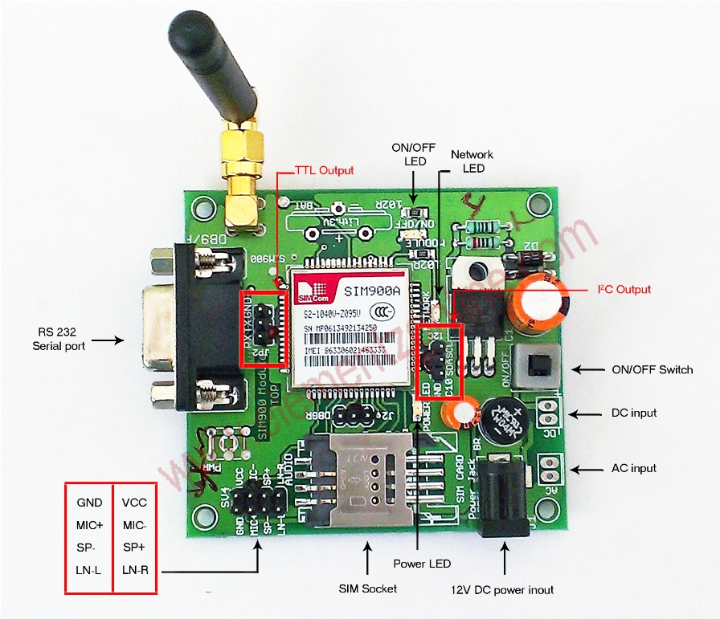

Fig:-GSM SIM900

DC Motor

A DC motor is any of a class of rotary electrical machines that converts direct current electrical power into mechanical power. The most common types rely on the forces produced by magnetic fields. Nearly all types of DC motors have some internal mechanism, either electromechanical or electronic, to periodically change the direction of current flow in part of the motor.

DC motors were the first type widely used, since they could be powered from existing direct-current lighting power distribution systems. A DC motor's speed can be controlled over a wide range, using either a variable supply voltage or by changing the strength of current in its field windings. Small DC motors are used in tools, toys, and appliances. The [universal motor](https://en.wikipedia.org/wiki/Universal_motor) can operate on direct current but is a lightweight motor used for portable power tools and appliances. Larger DC motors are used in propulsion of electric vehicles, elevator and hoists, or in drives for steel rolling mills. The advent of power electronics has made replacement of DC motors with [AC motors](https://en.wikipedia.org/wiki/AC_motors) possible in many applications.

**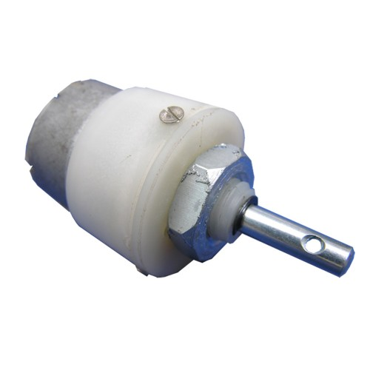**Fig:-DC Motor

**Moisture Sensor**

Soil moisture sensors measure the volumetric [water content](https://en.wikipedia.org/wiki/Water_content) in [soil](https://en.wikipedia.org/wiki/Soil).[[1]](https://en.wikipedia.org/wiki/Soil_moisture_sensor#cite_note-1) Since the direct [gravimetric measurement](https://en.wikipedia.org/wiki/Gravimetric_analysis) of free soil moisture requires removing, drying, and weighting of a sample, soil moisture sensors measure the volumetric water content indirectly by using some other property of the soil, such as electrical resistance, dielectric constant, or interaction with [neutrons](https://en.wikipedia.org/wiki/Neutron), as a proxy for the moisture content. The relation between the measured property and soil moisture must be calibrated and may vary depending on environmental factors such as soil type, [temperature](https://en.wikipedia.org/wiki/Temperature), or [electric conductivity](https://en.wikipedia.org/wiki/Electric_conductivity). Reflected [microwave](https://en.wikipedia.org/wiki/Microwave) radiation is affected by the soil moisture and is used for [remote sensing](https://en.wikipedia.org/wiki/Remote_sensing) in [hydrology](https://en.wikipedia.org/wiki/Hydrology) and agriculture. Portable probe instruments can be used by farmers or gardeners.

Soil moisture sensors typically refer to sensors that estimate volumetric water content. Another class of sensors measure another property of moisture in soils called [water potential](https://en.wikipedia.org/wiki/Water_potential); these sensors are usually referred to as soil water potential sensors and include [tensiometers](https://en.wikipedia.org/wiki/Tensiometer_%28soil_science%29) and gypsum blocks.

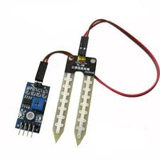

Fig:-Moisture Sensor

#### PCB Layout

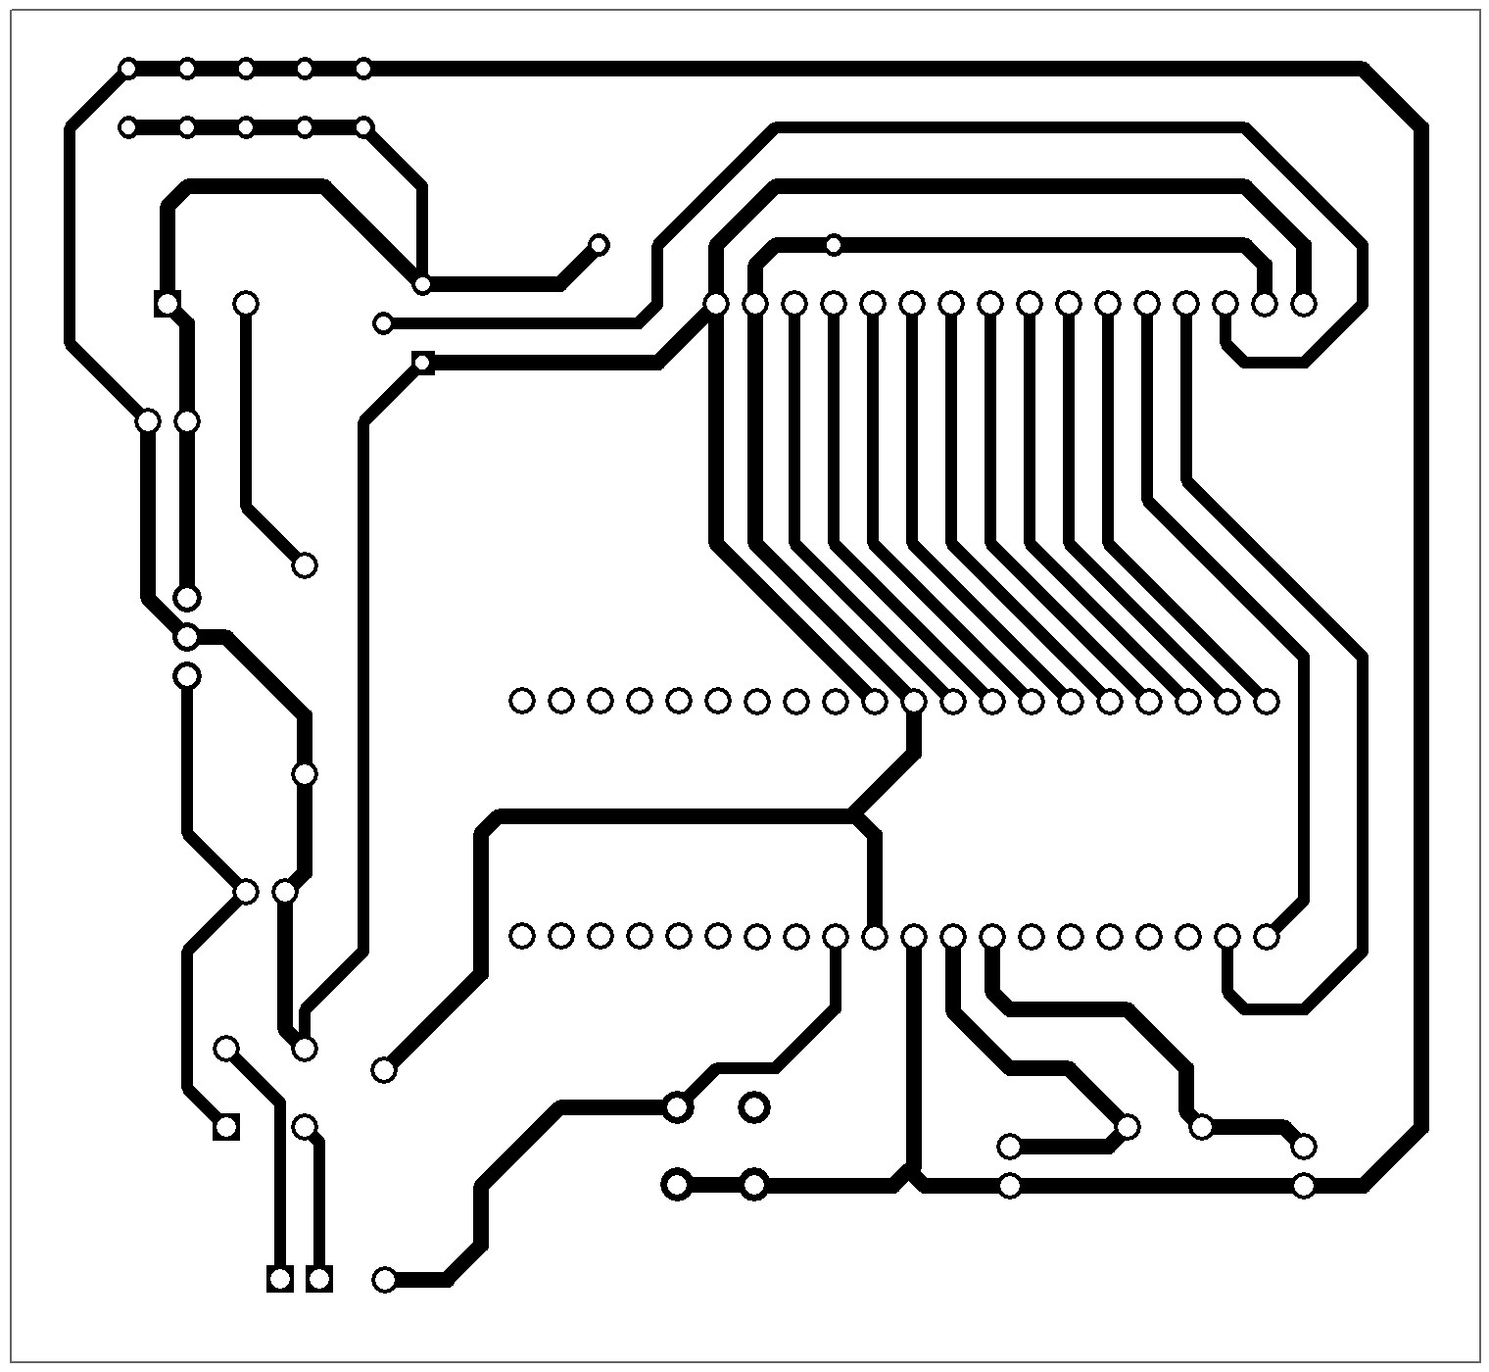

**Demo picture**

**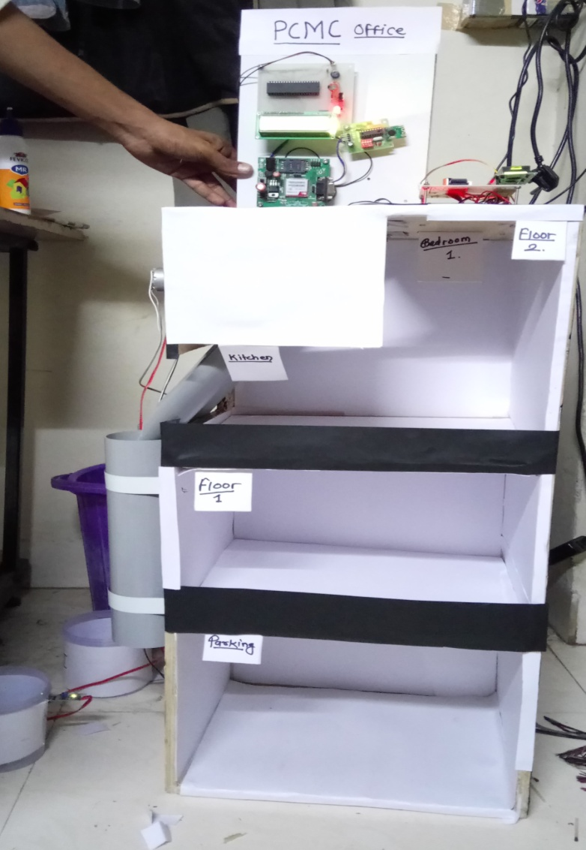**

**Applications and Advantages:**

#### 1) To collect dustbins placed at public places in city.

#### 2) This project can also be used in college / university campus

#### 3) This project can also be used in companies

#### 4)Many times Garbage dust bin is overflown and many animals like dog

#### or goat enters inside or near the dustbin. This creates a bad scene. Also

#### some birds are also trying to take out garbage from dust bin. This project

#### can avoid such situations.

**Future Development:**

#### 1. We can add GPS modem to this project. This will help to track the

#### position in case there are more dustbins

**REFERENCES**

#### [1]. Yang Kai, Zhang Junmei, Li Wenbin, Yang Liu, GaoLin,XueHuixia,“Weighing System of Fruit-Transportation Gyrocar Based on ARM” IEEE computer society,2011 DOI 10.1109/ICMTMA.2011.253.

#### [2]. Arebey M.,Hannan, M.A. ; Basri, H. , Abdullah, H. “Solid waste monitoring and management using RFID, GIS and GSM ”IEEE Student Conference on Research and Development (SCOReD), 2009.

#### [3]. Arebey, M. ;Hannan, M.A. ; Basri, H. ; Begum, R.A., “Solid waste monitoring system integration based on RFID, GPS and camera”, IEEE International Conference on Intelligent and Advanced Systems (ICIAS), 2010.

#### [4]. Islam, M.S. ;Arebey, M. ; Hannan, M.A. ; Basri, H., “Overview for solid waste bin monitoring and collection system”,IEEE International Conference on Innovation Management and Technology Research (ICIMTR), 2012.

#### [5]. Alberto Rovettaa, Fan Xiuminb, c, Federico Vicentinia, , , Zhu Minghuab, c, Alessandro Giustia, He Qichang “Early detection and evaluation of waste through sensorized containers for a collection monitoring application” Science Direct Journal.

#### [6]. Issac, R;Akshai,M.”An effective solid waste management system for Thiruvalla Municipality in Android OS” IEEE Conference Publications , 2013.

#### [7]. Longhi,S ; Marzioni,D ; Alidori, E ; Di Buo,G.; Pris,M. ; Grisostomi, M. ; Pirro,M. ”Solid Waste Management Architecture Using Wireless Sensor Network Technology“ ,New Technology , Mobility and Security (NTMS),2012 5th International Conference.

#### [8]. Chen Tao; Li Xiang, “Municipal Solid Waste Recycle Management Information Platform Based On Internet of Things Technology”, Multimedia Information Networking and Security (MINES)